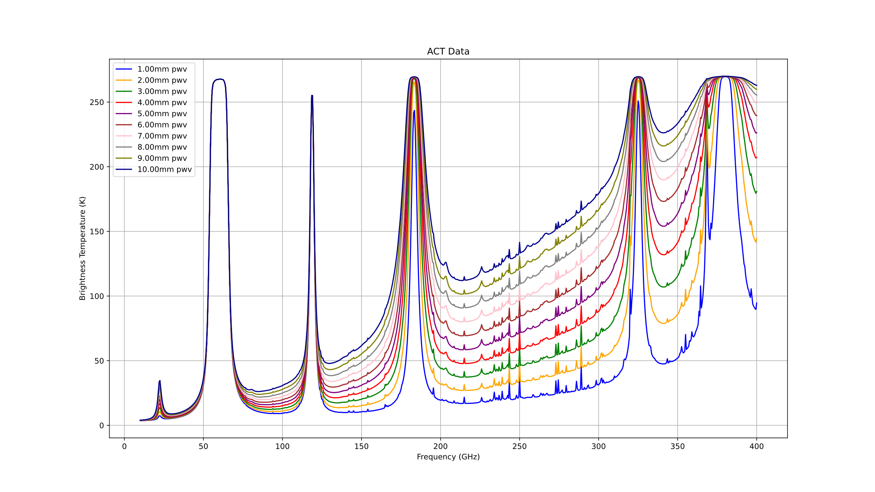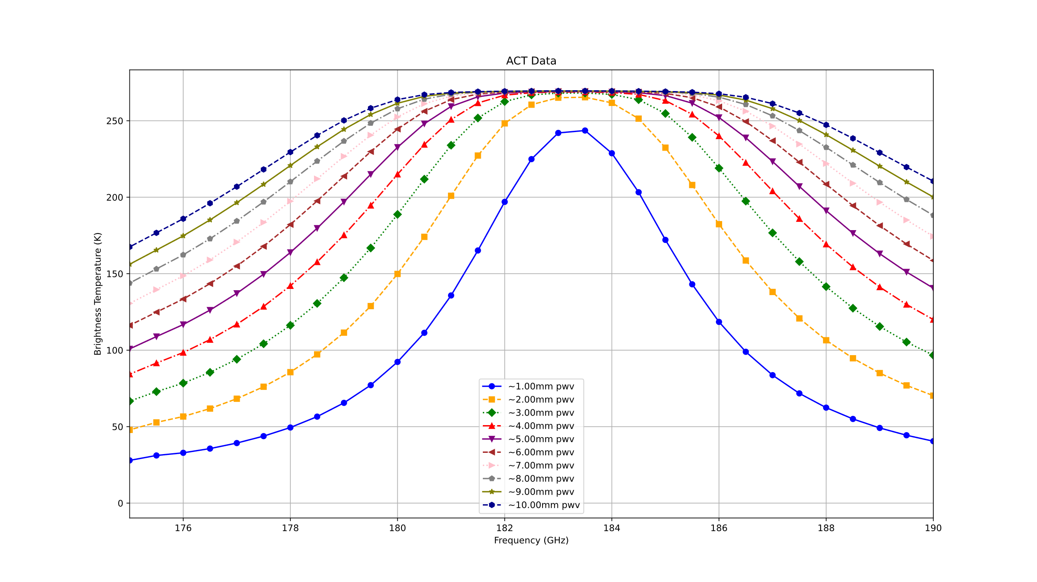
This figure shows the different PWV from 1 to 10 mm influence the brightness temperature in different frequencies. For our real measurement, we focus on the frequency between 170-190 GHz. We can see from the second figure that high PWV gives a more flat and higher brightness temperature, the less PWV give a more gauss shape and lower brightness temperature.

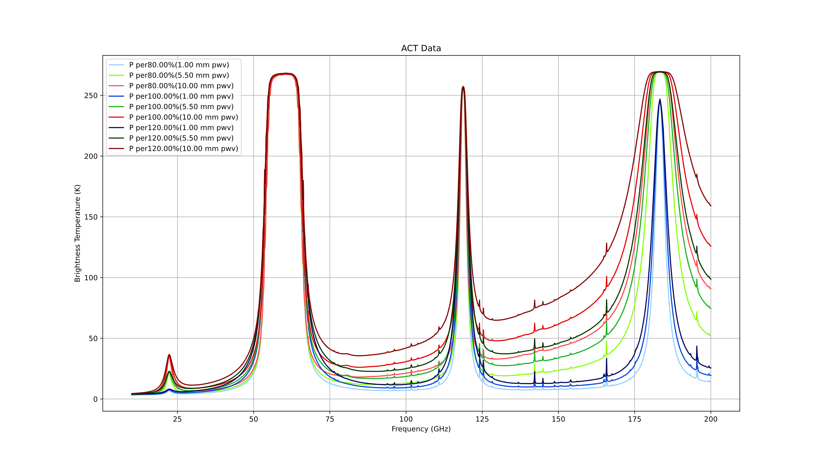Overall model for different pressure percentage with different PWV values, use similar color group(light or dark) to show same PWV value.
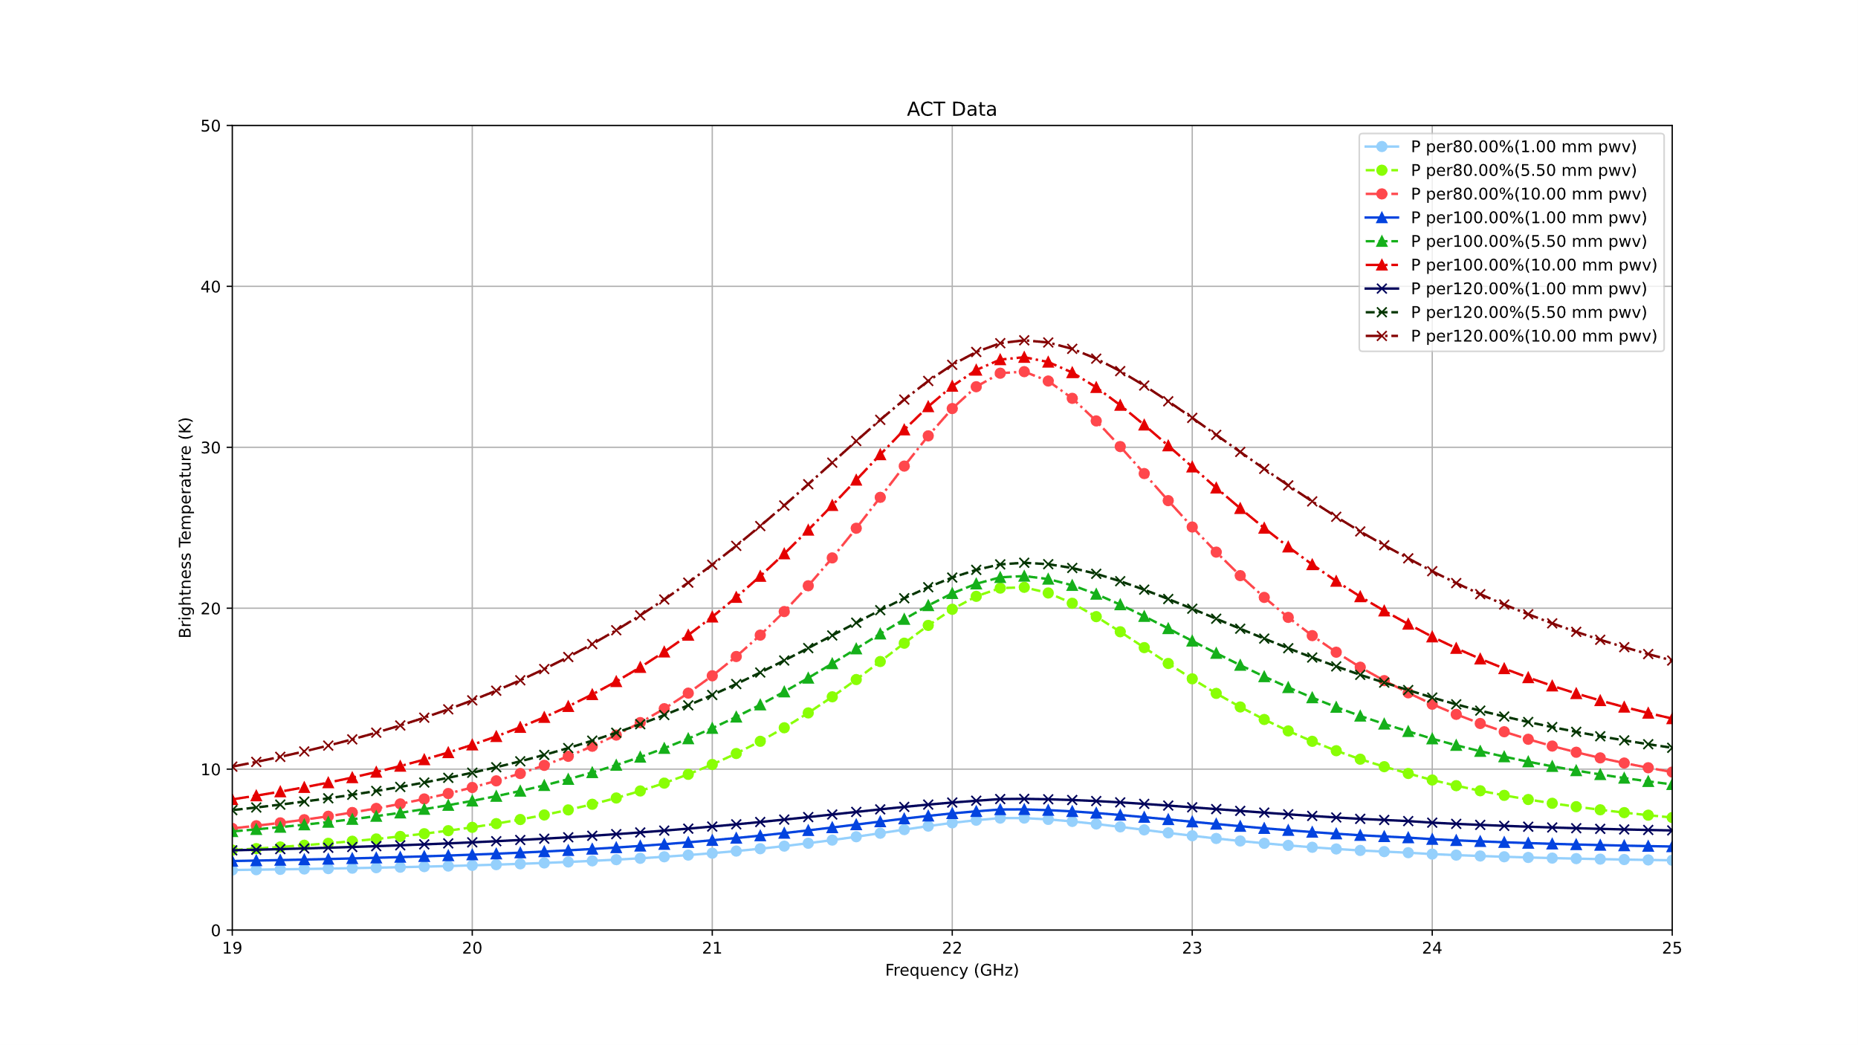The focus figure to the 19-25 GHz, similar color group(light or dark) to show same PWV value, same marker and line style show same percentage of pressure change.
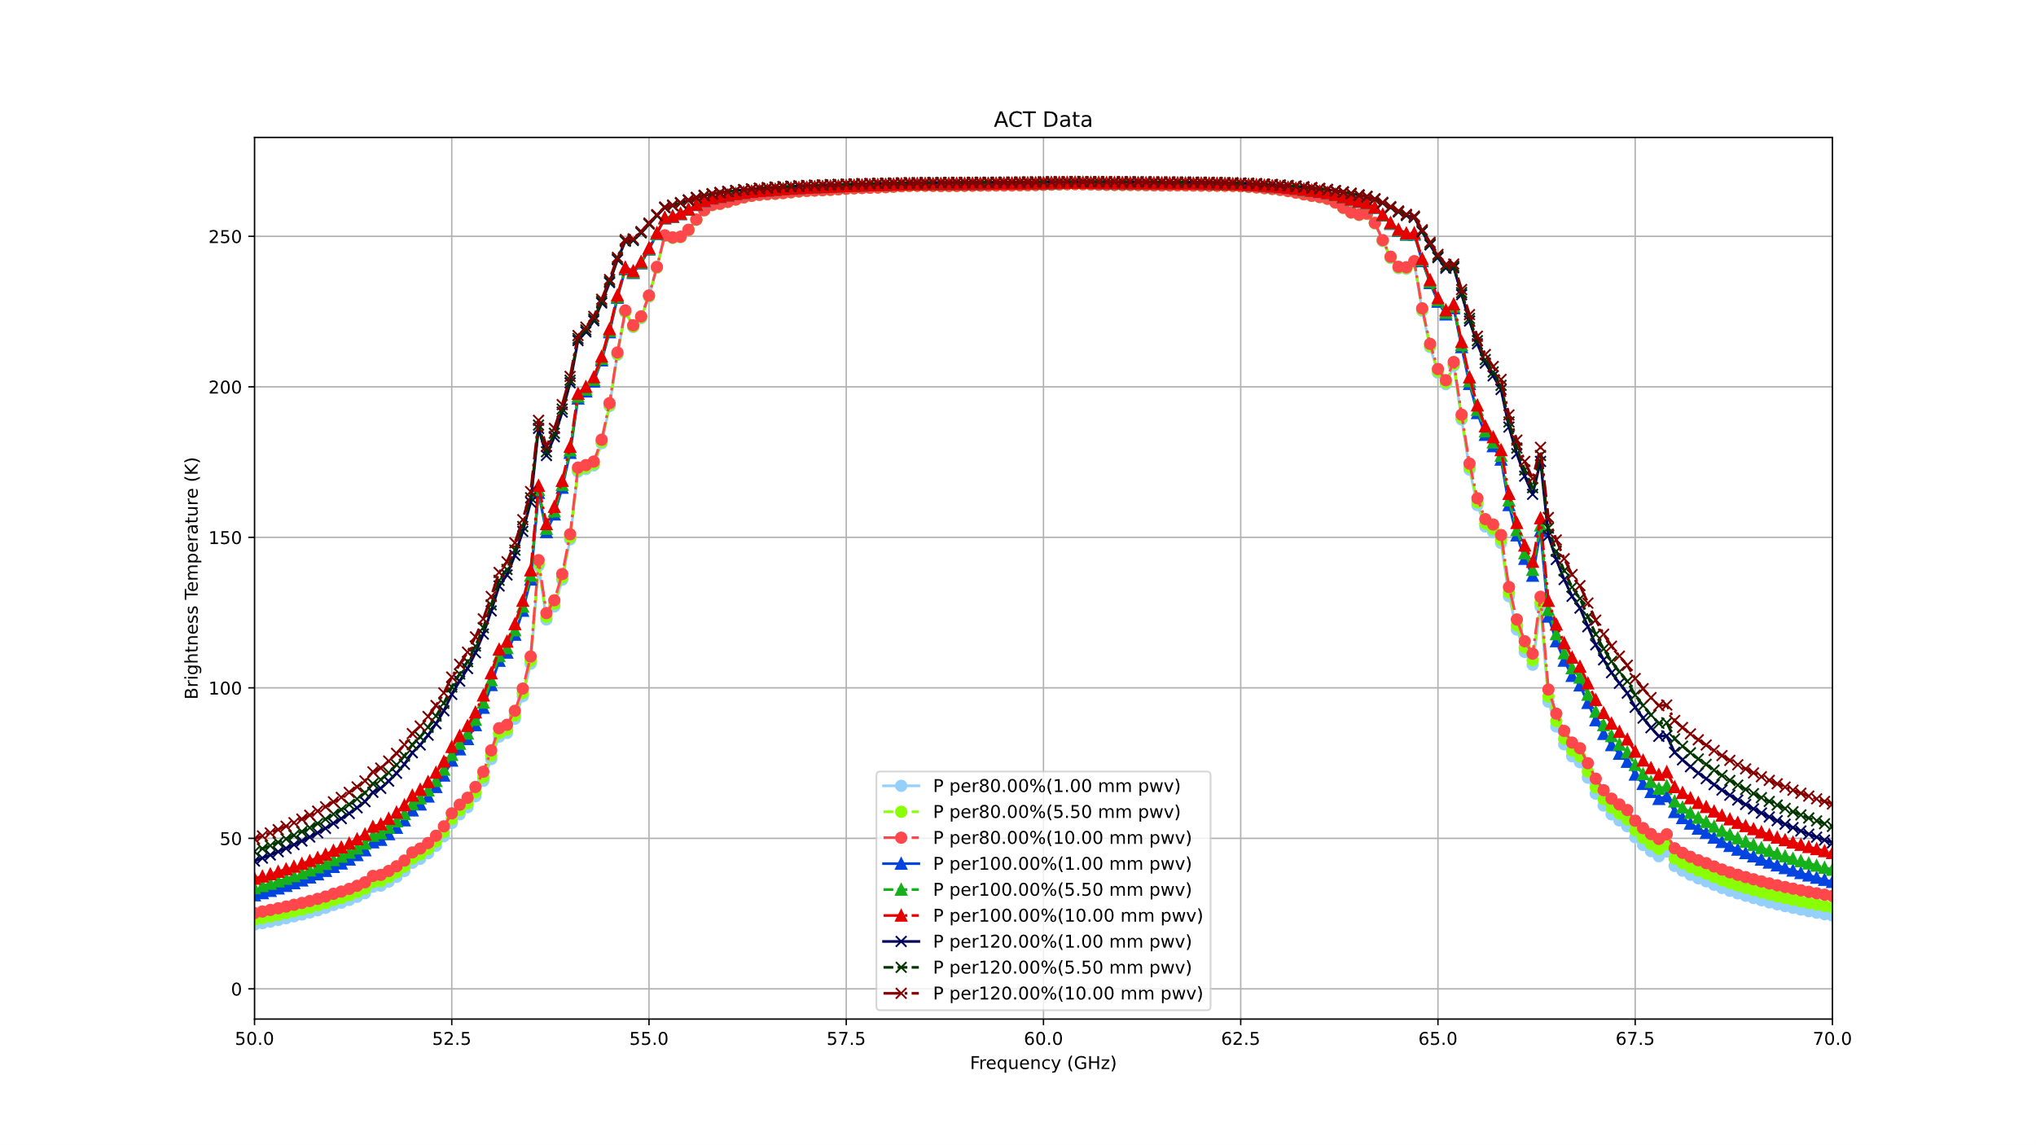The 50-70 GHz peak for the model, for pressure change between 80%-120% don’t have significant change.
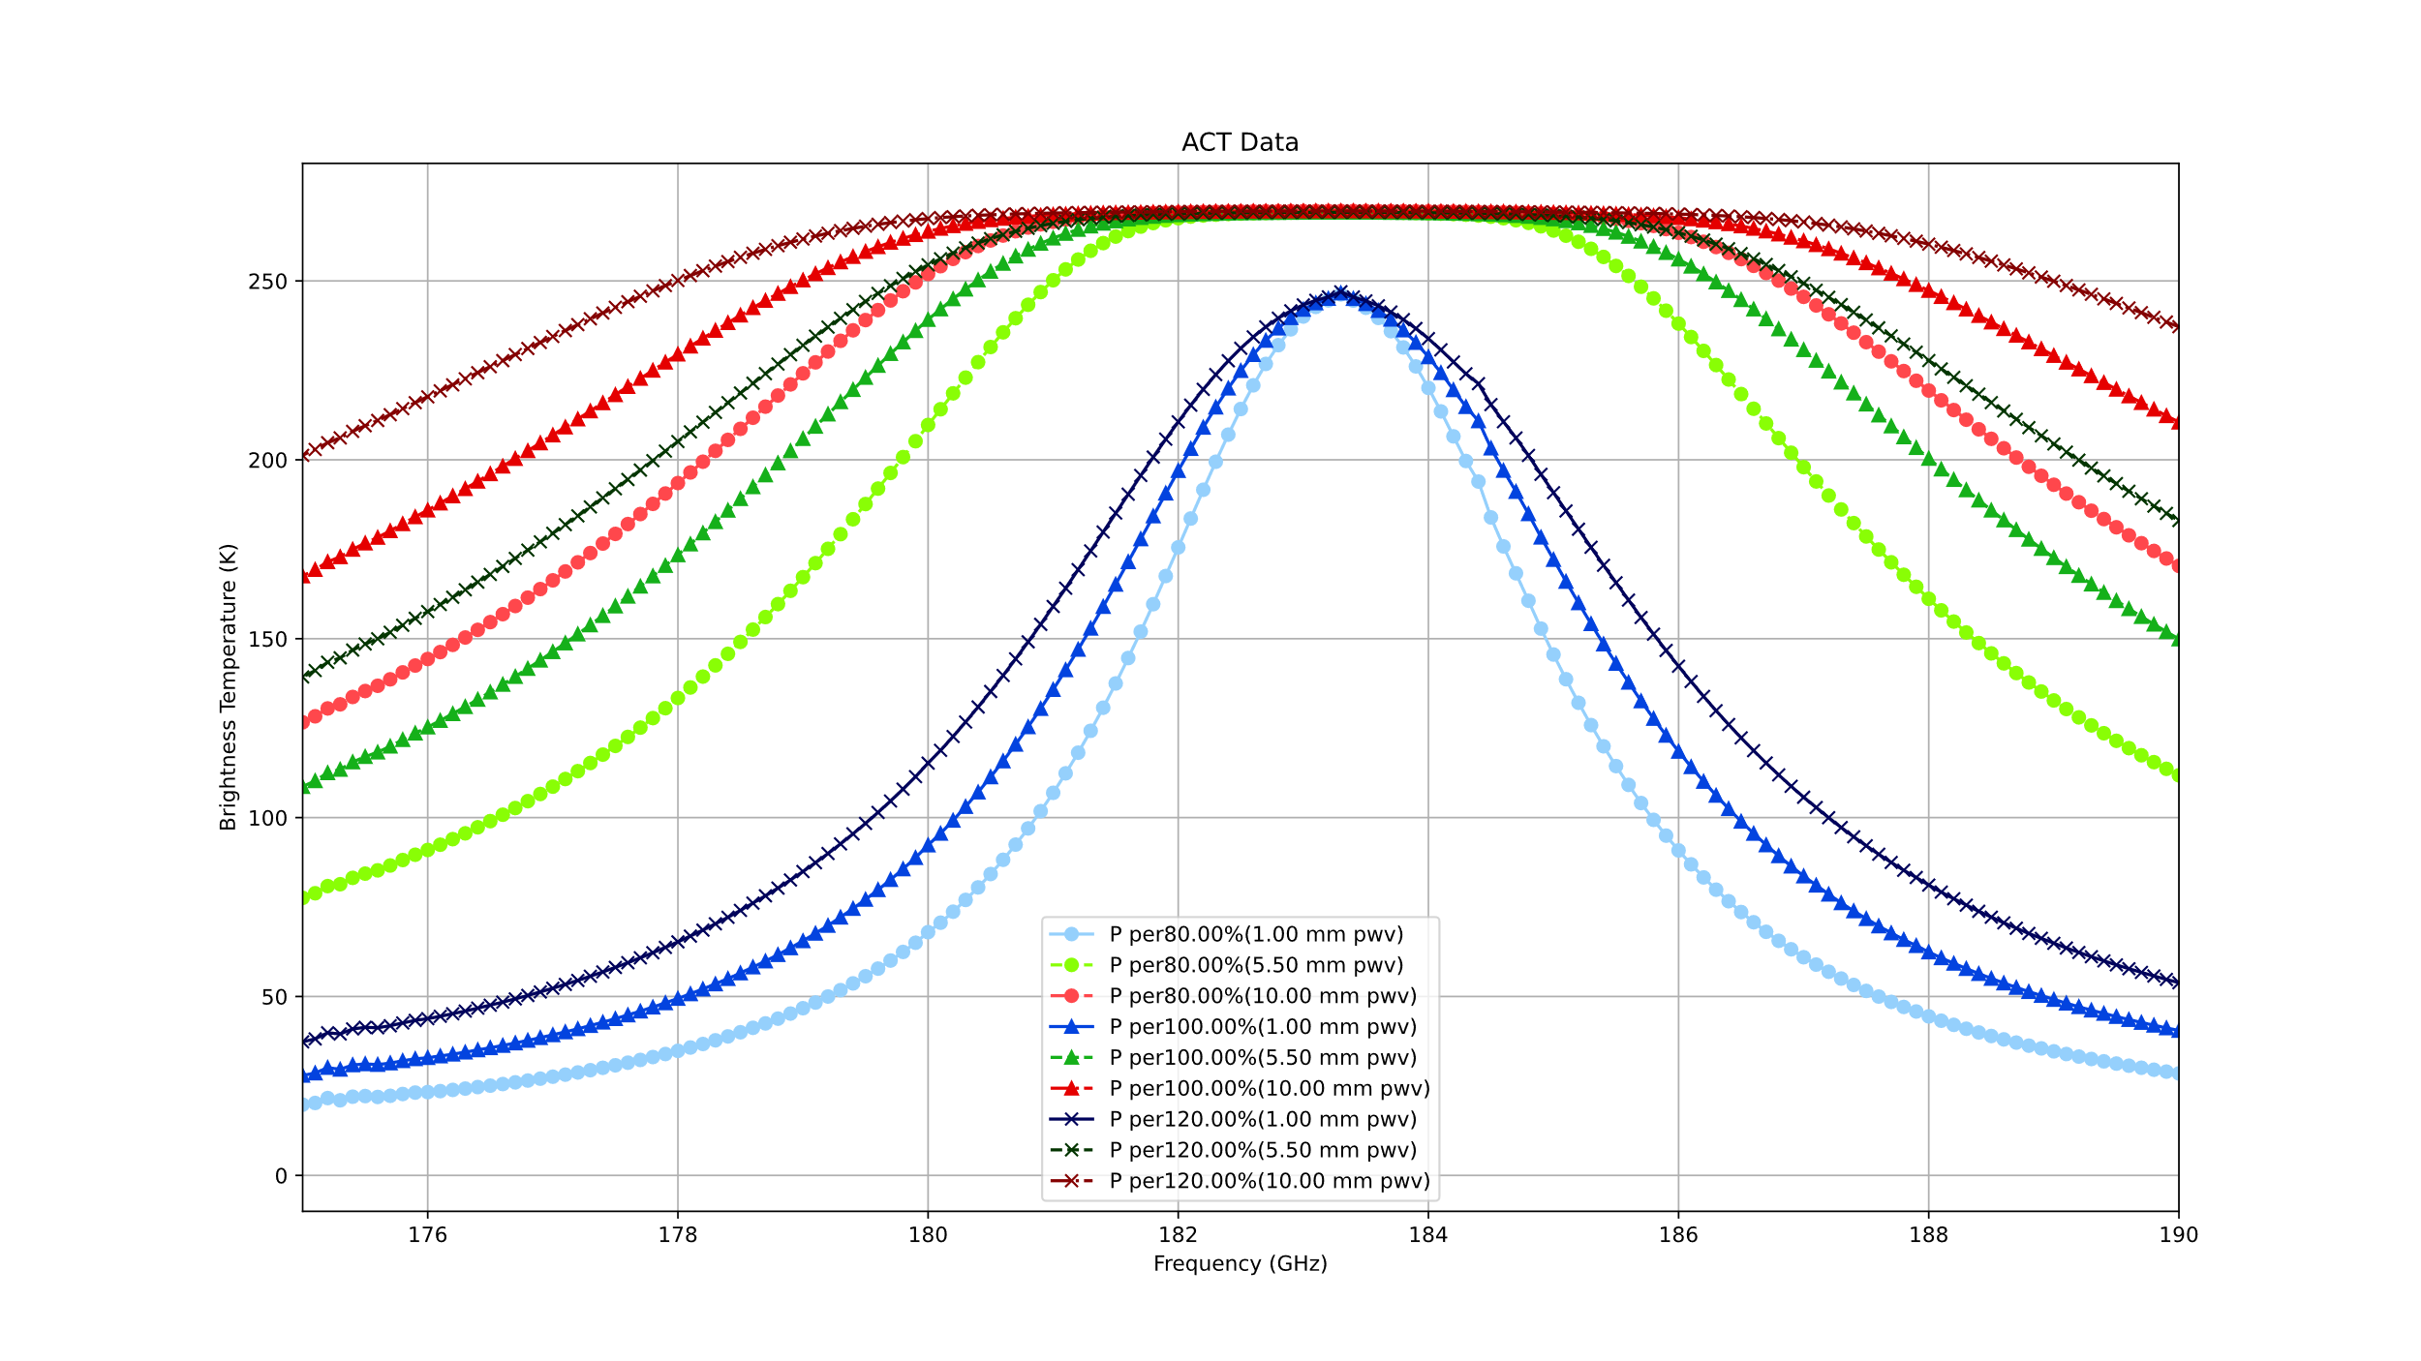The focus figure for the frequency between 175-190 GHz, the dark green line(5.5 mm PWV with 120% pressure) are on the top of the light red line(10 mm PWV with 80% pressure).

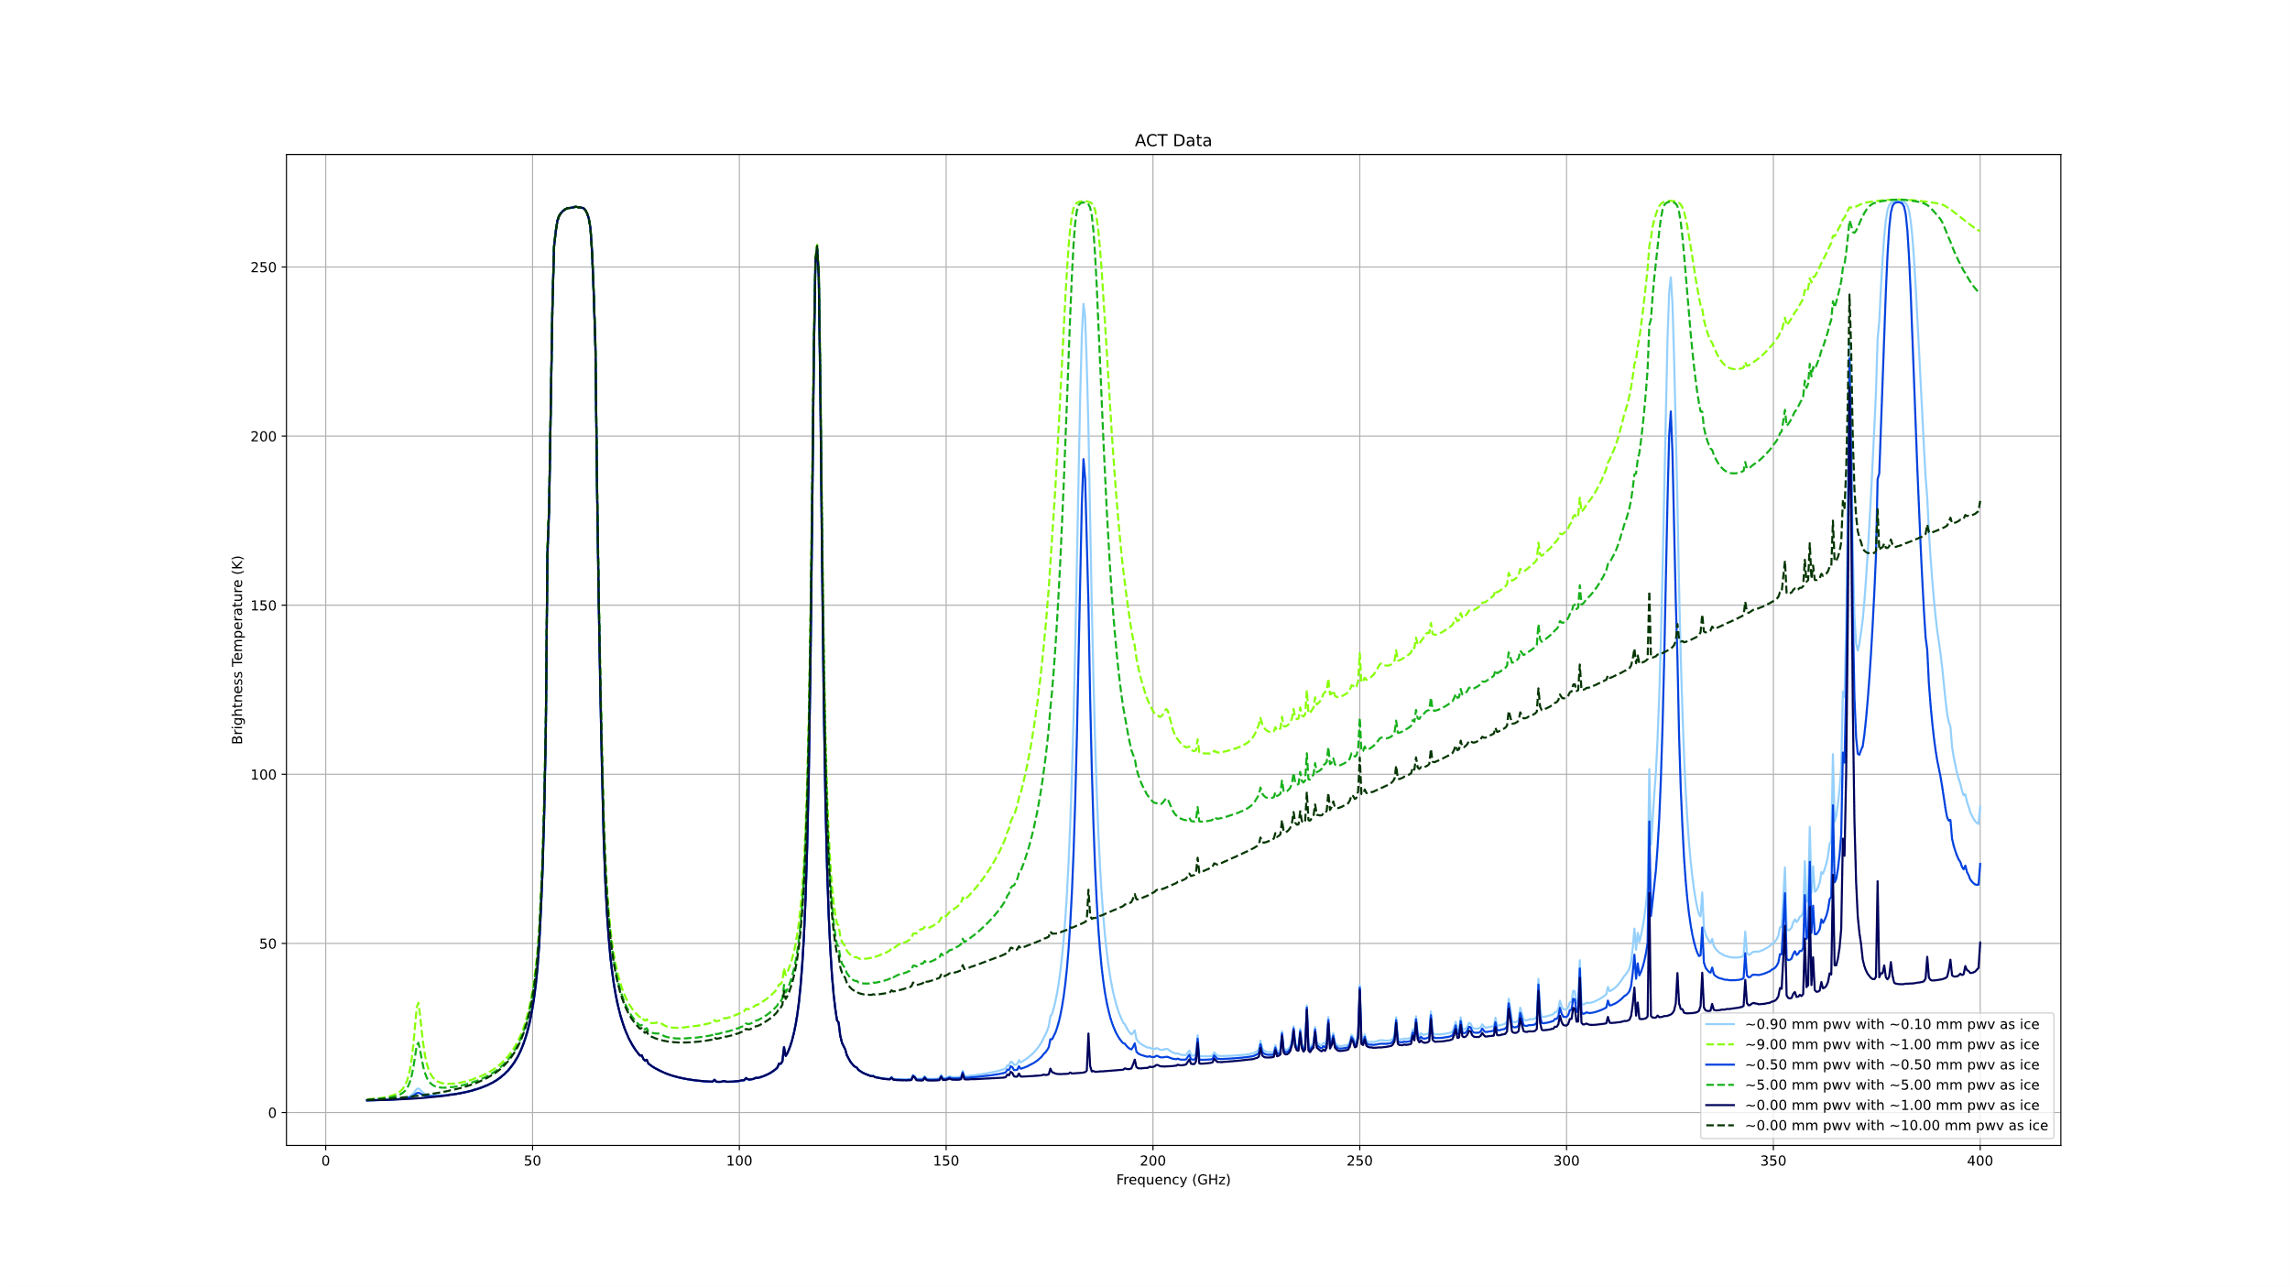 Overall model for different water vapor and ice mixing ration with different PWV values, use similar color group(light or dark) and line style to show same PWV value. Typically speaking, ice haven’t a value of PWV, in this and follow figures the “PWV as ice” means the same density of the ice if there are water vapor, in another words, same PWV value of ice means that ice have same column density as water vapor.

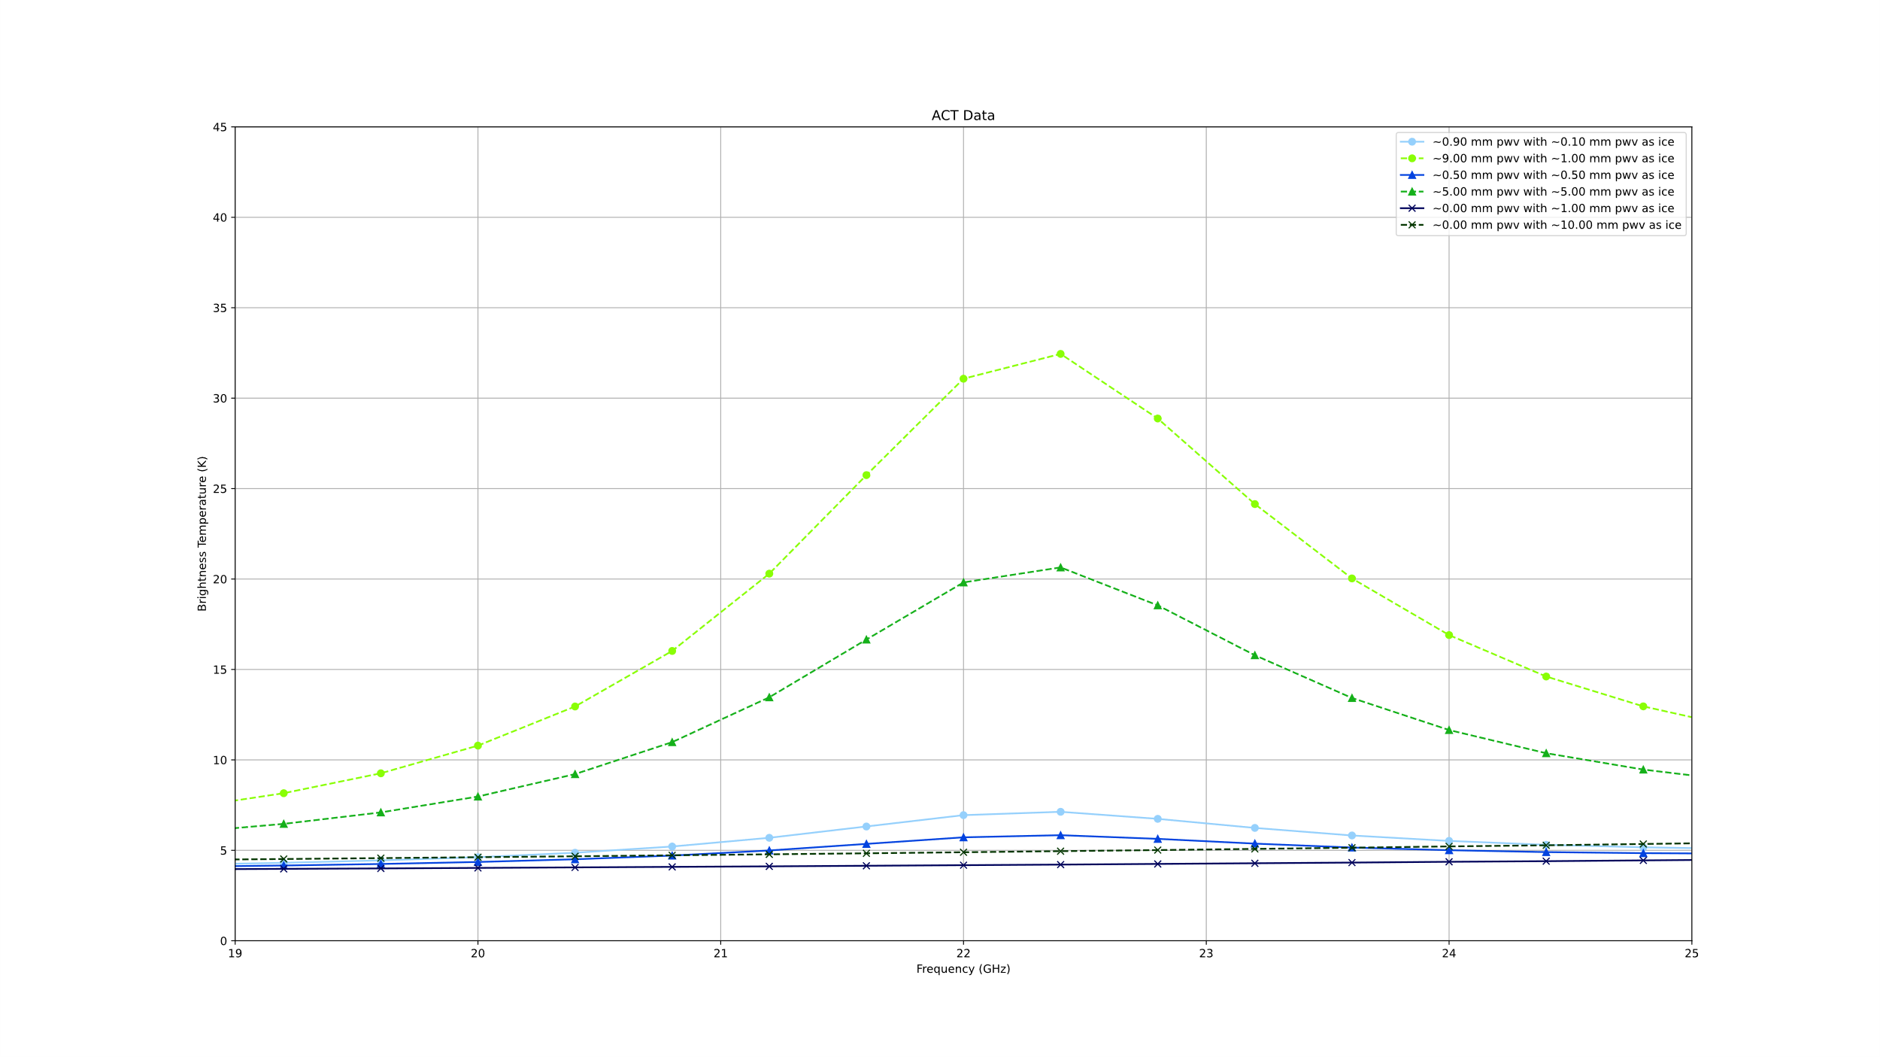
This is a low frequency figure, use same marker(dot, triangle or cross) to show same water vapor and ice mixing ratio. The dark green line(only have ice for 10mm PWV ) is close to the blue group(total 1 mm PWV with different ice mixing ratio)

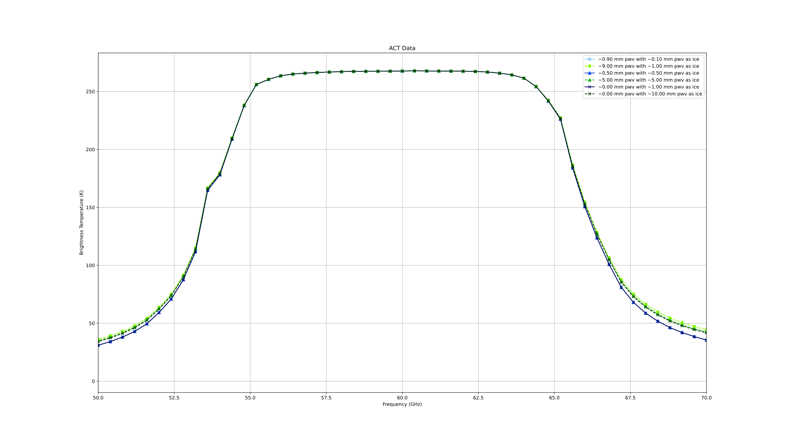 The 50-70 GHz peak for the model, whether water is vapor or ice don’t have significant influence on this.
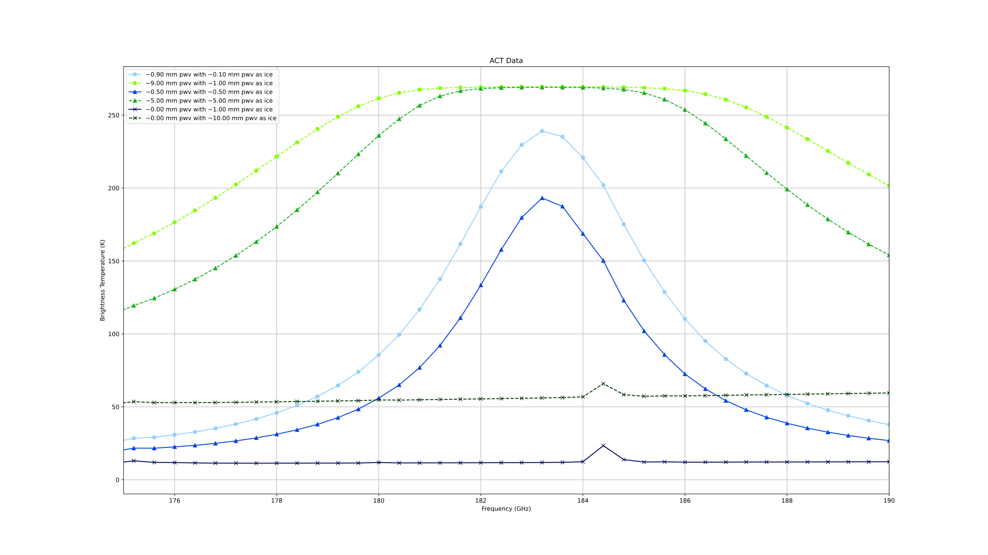
The 175-190 GHz figure, the light green(only ice as 10 mm PWV) is flat but higher brightness temperature in beginning and last frequencies to light blue and blue line.

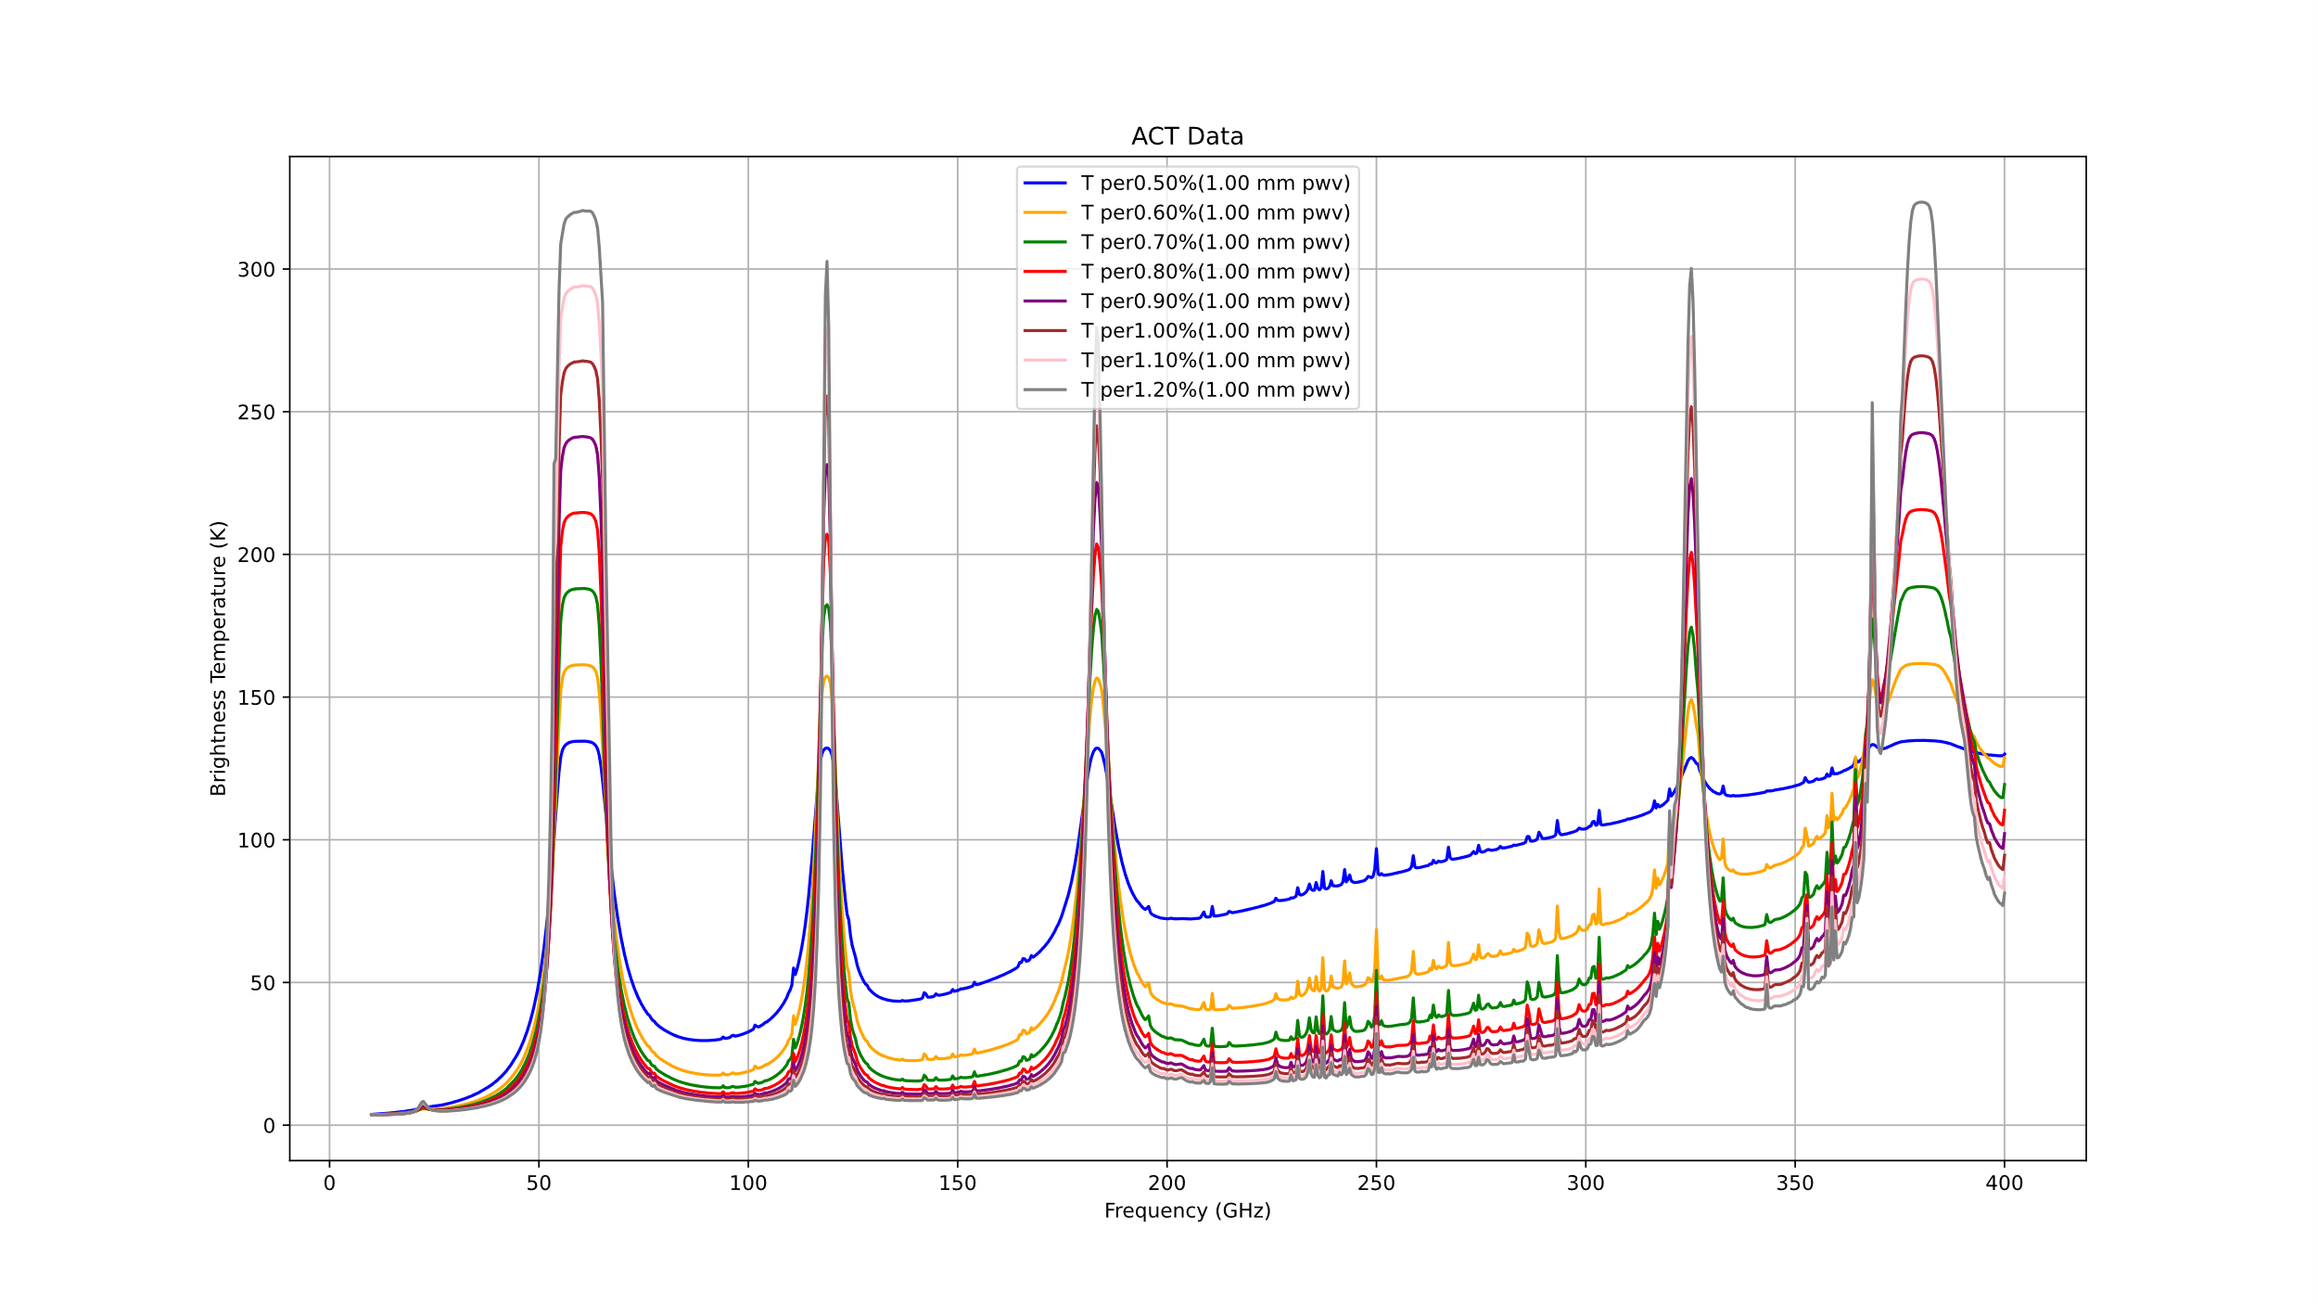
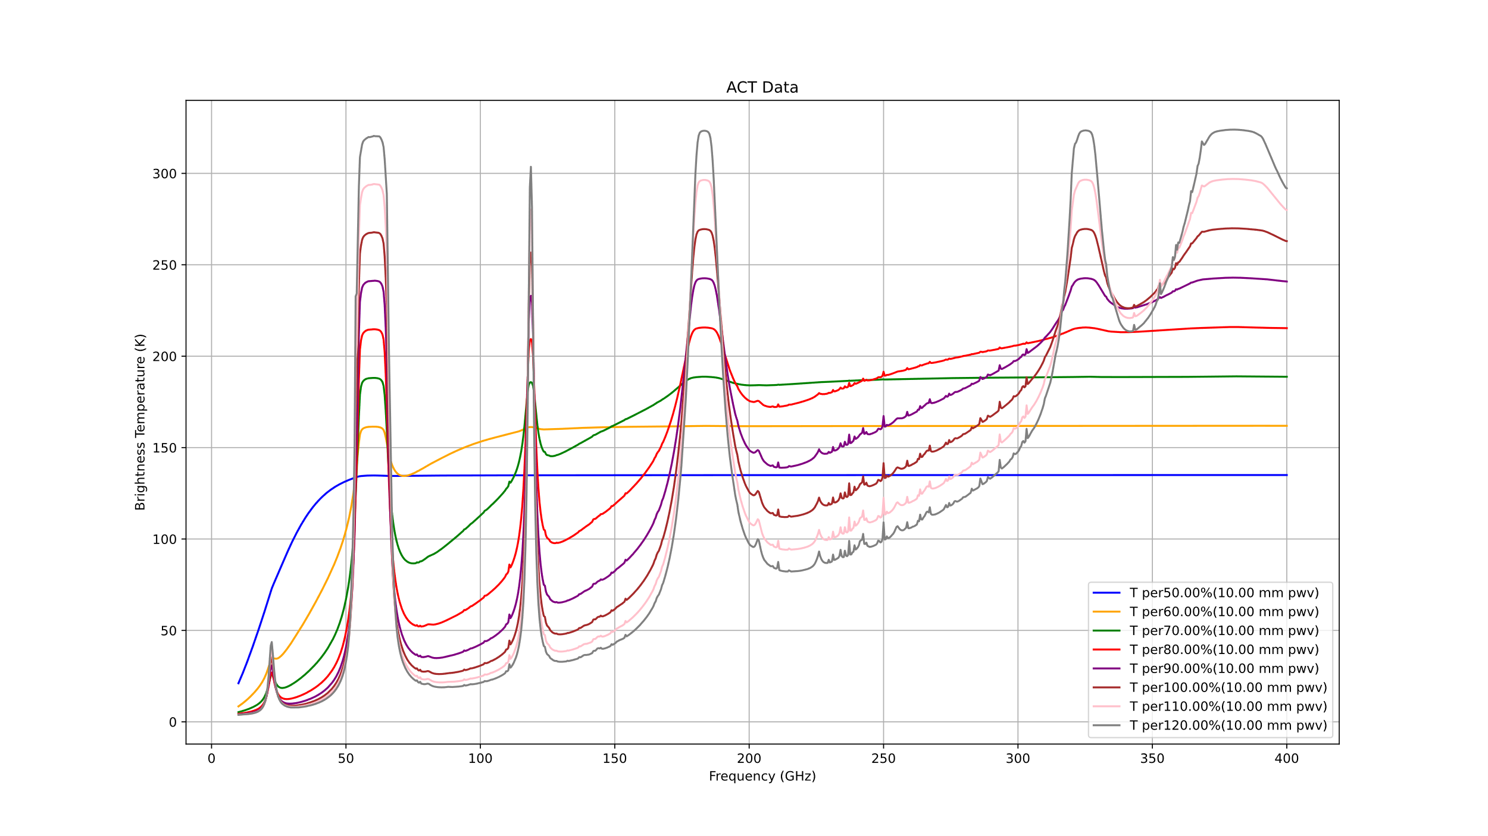
The overall figure for the percentage change of the temperature with two PWV values. The blue line for 1 mm PWV and red, green, yellow and blue lines for 10 mm PWV perform like the data out of the am package limitation.

What I did for amc files:
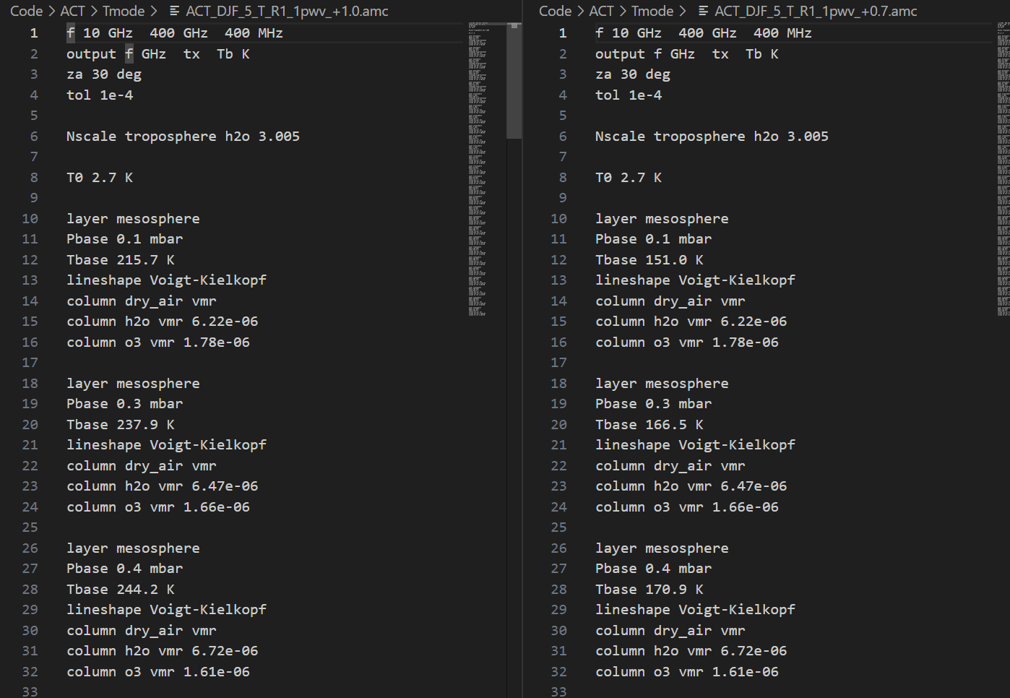
The only change I made is let original Tbase value times the percentage of change.
Like in the ACT_DJF_5_T_R1_1pwv_+1.0.amc file which means the temperature doesn’t change, the first Tbase is 215.7 K. So, the ACT_DJF_5_T_R1_1pwv_+0.7.amc file means all Tbase times 0.7, which first layer Tbase is about $215.7*0.7= 151.0 K$.

